**Deployment Manual**

Team Members : -

1. Velmurugan K

2. Thippusulthan U

3. Sweety Catherine

4. Yazhini S

5. Seema Singh

**Other Details: -**

**Port Numbers used for Bank Account Management System application:**

1. **Tomcat Port Number used for Spring Boot application in this project:** 8090
2. **Angular Port Number used for Angular application in this project: 4205**

**Version of Tech Stack:-**

* **Angular --- 8**
* **Spring Boot --- 2.5.10**
* **Java --- 8**
* **JDK – 1.8**
* **Oracle Database --- 11g**

1. The **GitHub Public Repository Link** for the Project **Bank Account Management**

**GitHub Link** 🡪[**https://github.com/thegirlseema/Bank_Account_Management.git**](https://github.com/thegirlseema/Bank_Account_Management.git)

1. How to **clone** the **project** from ***GitHub to Developers* system**

GitBash 🡪 We are using GitBash for working in the GitHub

STEP 1: Download the GitBash in your system

STEP 2: Create an empty workspace for the git project to be cloned (optional)

STEP 3: Open GitBash 🡪 use the command cd <path of the directory you want to clone the project with ‘/’ instead of ‘\’>

STEP 4: Now, use command “git clone <git repository URL >

[ The Git Hub project is cloned in the developer system]

1. How to **import Project** in ***ECLIPSE IDE***

STEP 1: Go to **FILE** in ECLIPSE WORKSPACE

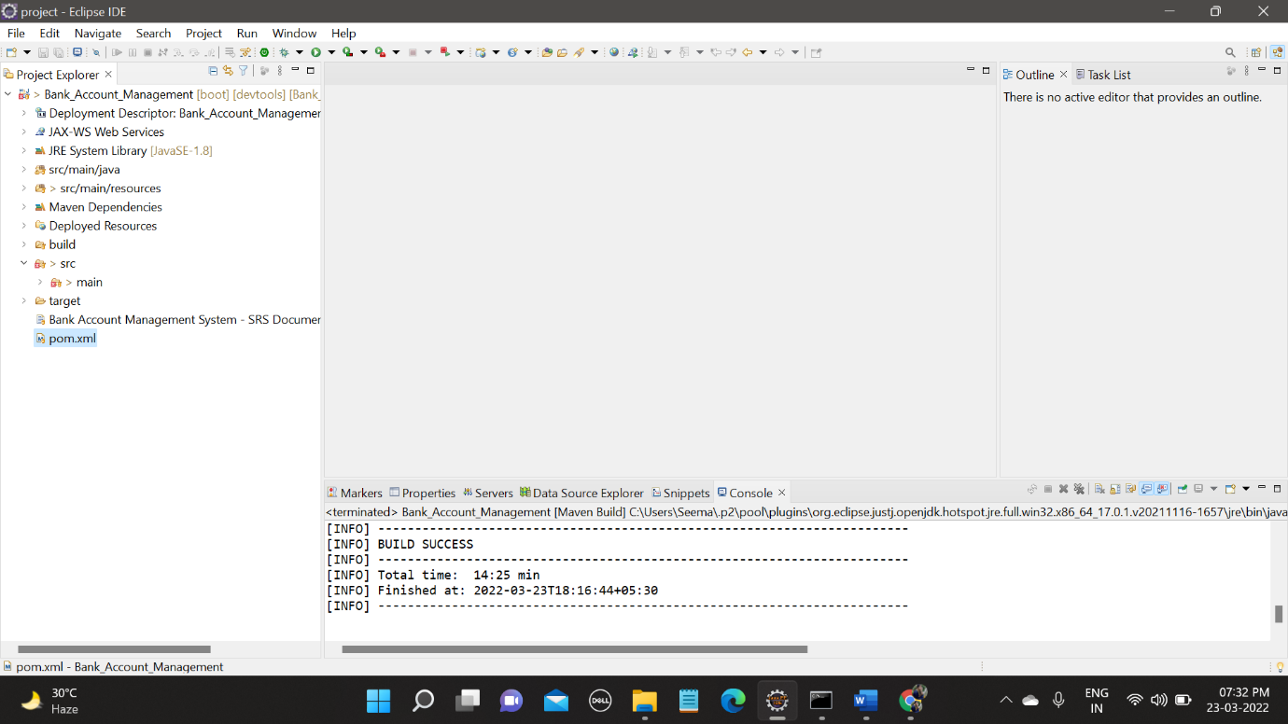

STEP 2: Then select 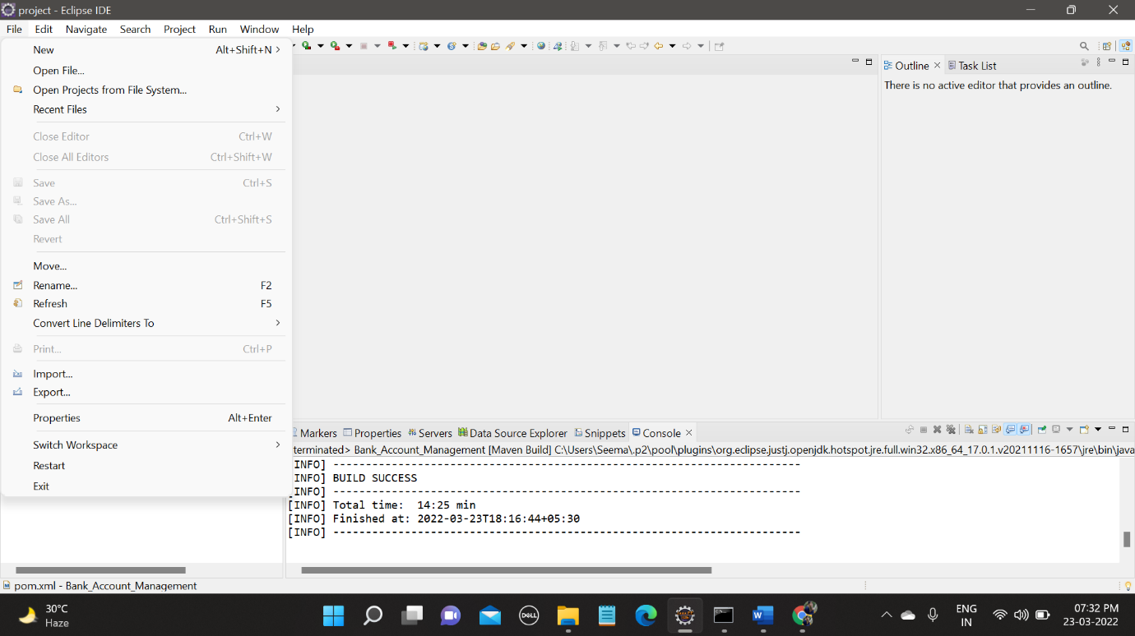

STEP 3: Then go to your workspace folder from directory 🡪 Select the cloned project from the directory 🡪 Finish

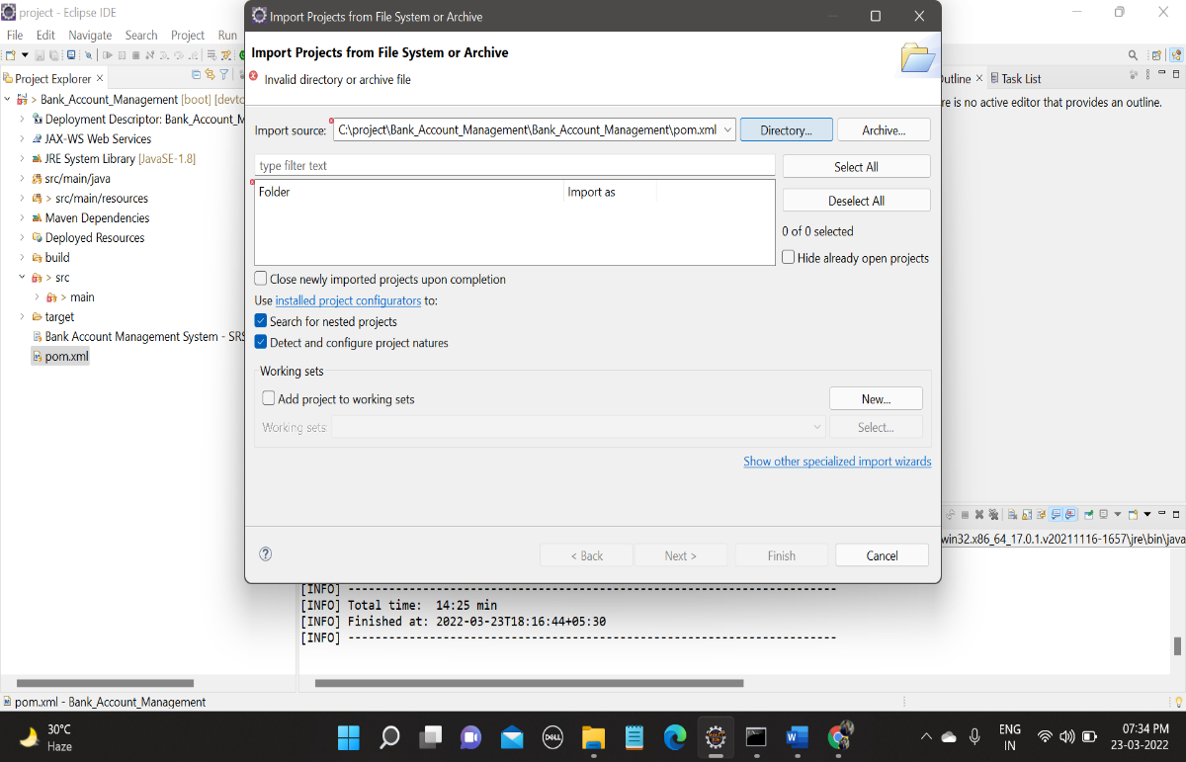

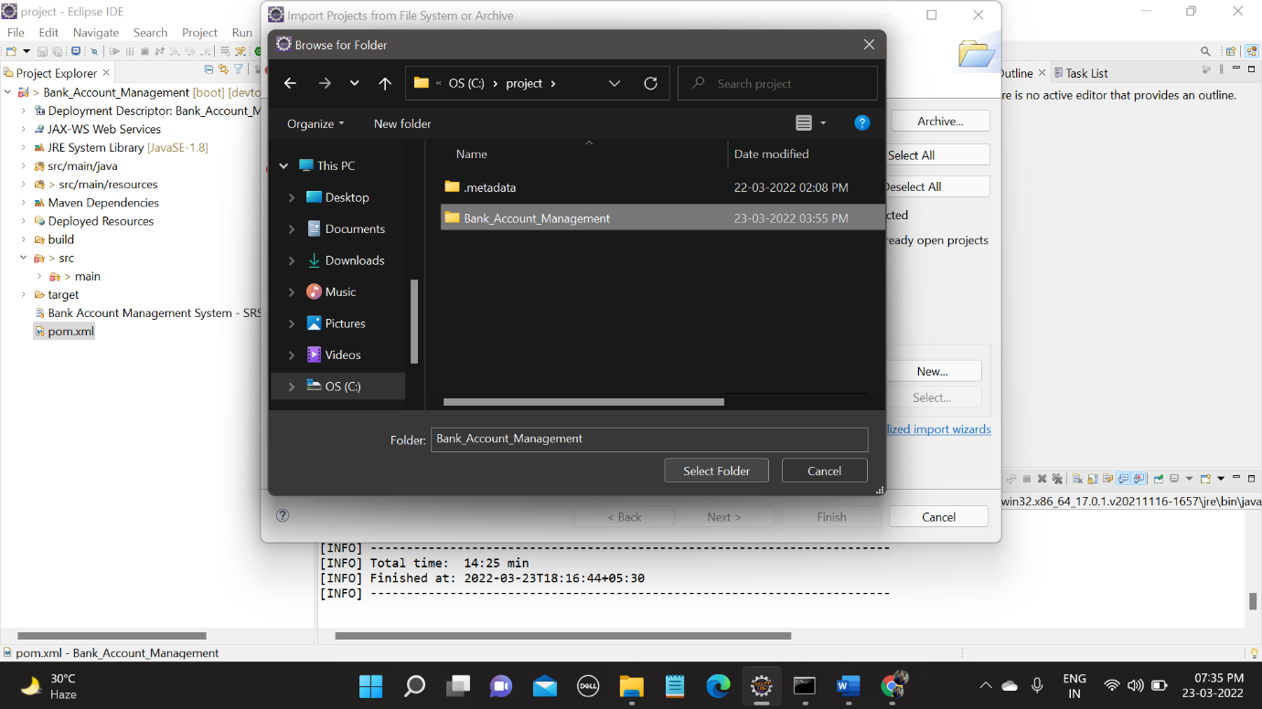

Following the above steps, you can import the project successfully in your ECLIPSE IDE workspace

1. **Changes to be done for the DB(Database)**

* The **GitHub Public Repository Link** for the Project **Bank Account Management DB Script**

**GitHub link 🡪** <https://github.com/thegirlseema/Bank_Account_Management/tree/main/Database%20Script>

* *ECLIPSE IDE*

STEP 1: Go to the project folder 🡪 Expand the folder 🡪 src/main/resources 🡪 application.properties

STEP 2: Change the username and password for database🡪 To developer’s username and password

STEP 3: Save the application.properties file

STEP 4: In the same folder a file name as db.script.sql.txt is available . There CREATE TABLE query is given and INSERT query for few data are given. Run the queries in the developer’s Database .

1. **How to run Project in the *ECLIPSE IDE***

*ECLIPSE IDE*

STEP 1: Go to the project folder

STEP 2: Then right click

STEP 3: Then go to Run As option

STEP 4: Click on Maven Clean

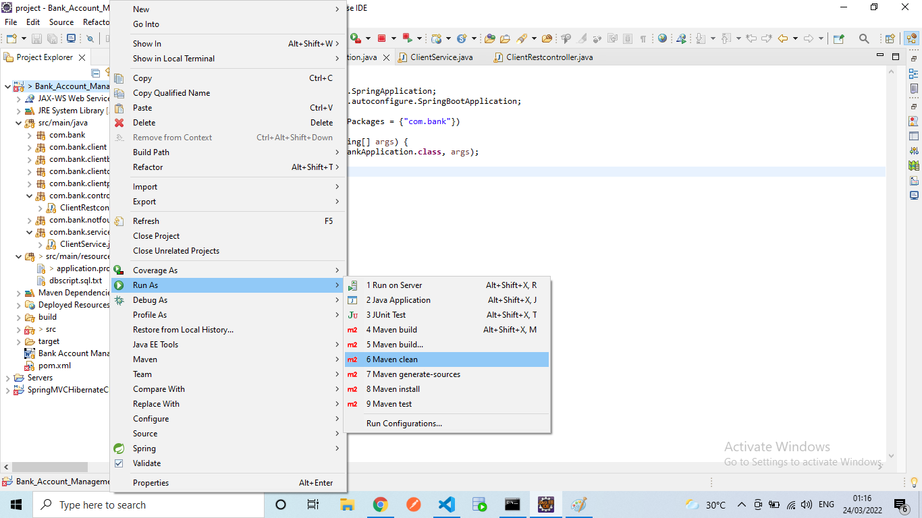

STEP 5: Check the Console, **BUILD SUCCESS** message should be displayed

STEP 6: Then, again go to Run As option

STEP 7: Click on **Maven Build**

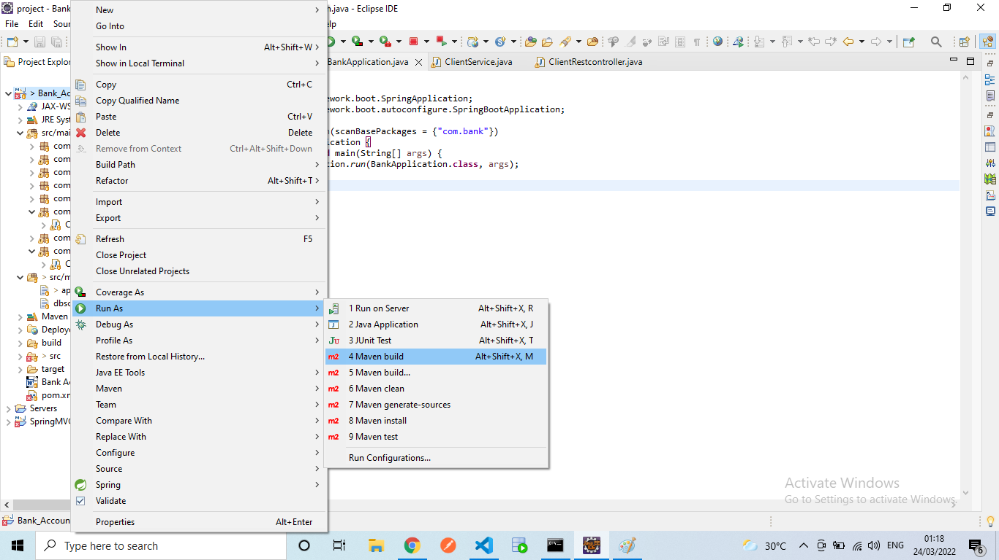

STEP 8: An Edit Configuration window will open; there a Goal option is found write **“clean install”** in the input space of goal. Also click on the **Skip Tests** checkbox. Then click on apply button, after that run button.

STEP 9: Check the Console, **BUILD SUCCESS** message should be displayed.

STEP 10: Go to src/main/java 🡪 com.bank (package ) 🡪 BankApplication.java

STEP 11: In BankApplication.java 🡪 Right click on the file and click on the run as option 🡪 select the Java Application or Spring Boot Application(this option will come only if you have spring boot tool installed in your eclipse)

STEP 12: Check the console weather the message “ Application is running ” is shown or not.

[ If all the above steps are completed , that means the Backend Java code is running successfully in your system]

1. How to **run Angular** using **Command Prompt(CMD)**

STEP 1: Go to the project folder in eclipse

STEP 2: Expand the project folder, src 🡪 main 🡪 webapp 🡪 views 🡪 bankApplication .

STEP 3: Then copy the path of bankApplication folder (right click on the folder 🡪 properties 🡪 there is location row, copy the path from there).

STEP 4: Open the **Command Prompt**.

STEP 5: Use the command “**cd <paste the copied path>”**

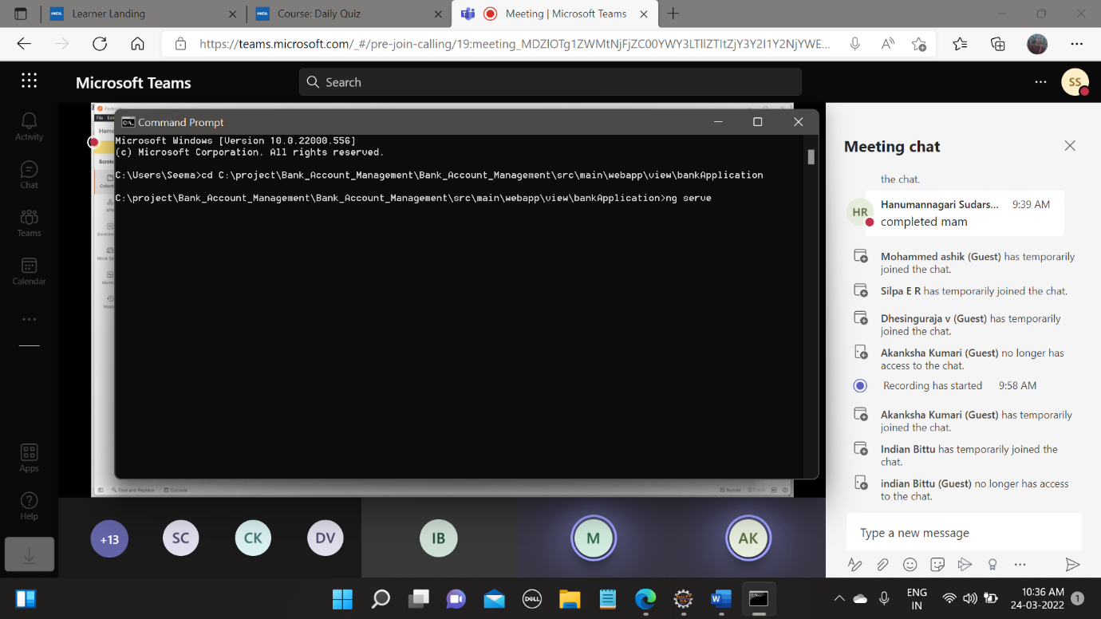

STEP 6: The command prompt will now go to the given path location. Now, if you have any other angular project already existing in the system then , copy the **node_modules** from there else you can also run the command **“npm install”**.

STEP 7: Once the installation is successful run the **“ng serve –port 4205”** command. (Angular by Default uses port 4200 but as we are using 4205 port for our project so we have to change the port number manually).

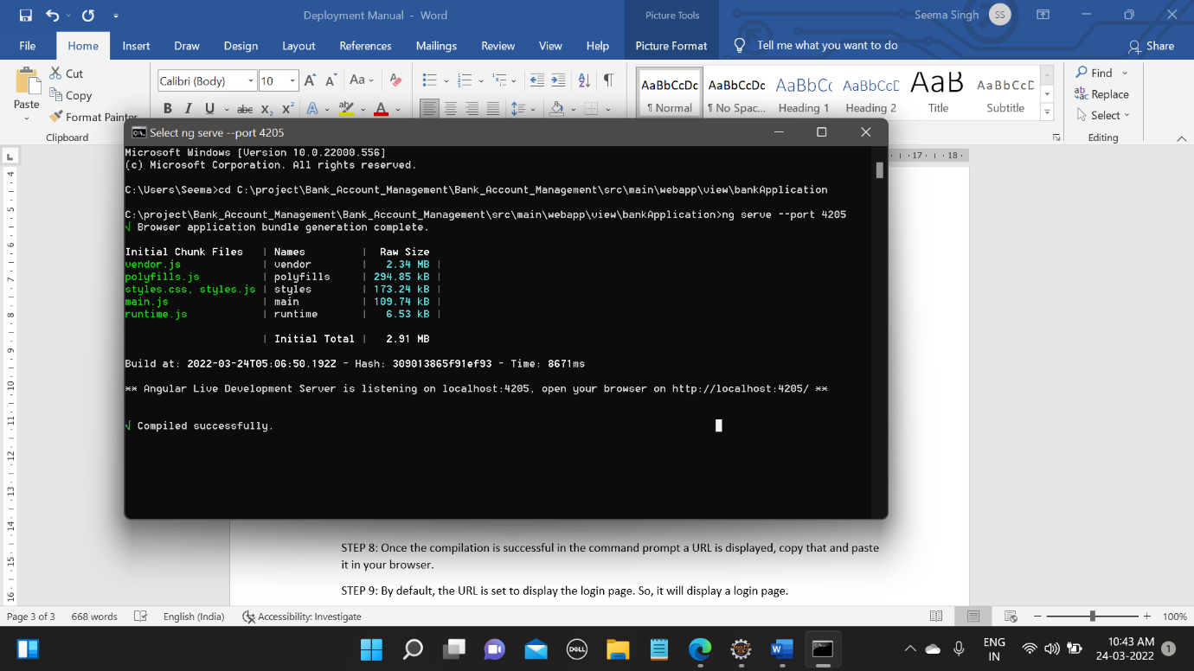

STEP 8: Once the compilation is successful in the command prompt a URL is displayed, copy that and paste it in your browser.



STEP 9: By default, the URL is set to display the login page. So, it will display a login page.

STEP 10: In login page we can use username – sanjay123 and password-1234 to login to the application .

STEP 11: After successful login 🡪 user is taken to home page 🡪

In homepage you can see the following functionalities :-

* Account Details
* Check Balance
* Last Transaction
* Total Transaction
* Money Transfer 🡪 a. Deposit b. Withdraw
* Logout